Bio :

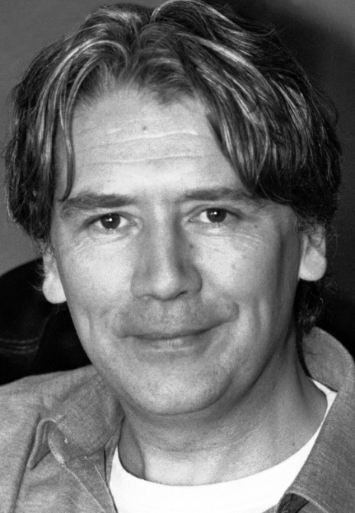

Andrew Harkin is a medical doctor (University College Dublin 1990) and psychotherapist. From 1997 to 1998 he completed a two year postgraduate training with the Sensorimotor Psychotherapy Institute in Colorado, U.S.A.. For more than 5 years Andrew was a lead trainer with this organization, teaching psychiatrists, psychologists and psychotherapists in the fields of trauma and attachment across the United Kingdom, Europe, North America and Australia.
Andrew has also trained in other trauma related models such as EMDR, Brainspotting and Comprehensive Resource Model (CRM )
Additionally he is a teacher in Mindfulness Based Cognitive Therapy (MBCT) having trained with the Centre for Mindfulness Research and Practice at the University of Bangor, North Wales. In 2013, Andrew and his family emigrated to Western Australia to take a position as a Senior Therapist in a psychiatric day hospital. Andrew now divides his time between providing training across Australia for mental health clinicians in body based approaches to psychotherapy and a private practice in Bunbury.
Andrew recently gave a TED talk entitled ‘Mind the gap: Moving from the brain to the body’. Those interested can follow this link.
https://www.youtube.com/watch?v=yfcnRzcpTd4

Contact Details
Dr Andy Harkin
33 Picton Crescent
Bunbury
WA 6230
M: 04 3276 2534
P : 08 9792 5667
E: andrewjharkin@gmail.com
1 : Trauma and the body workshop ( 2 – 4 days material )

Current research is showing that trauma is largely remembered non-verbally, leaving the body and nervous system primed for future threat. Many traditional approaches lack techniques to work directly with this physical legacy of trauma; indeed the body has largely been left out of the ‘talking cure’. Through a combination of lecture material, experiential exercises and discussion this workshop will introduce a body oriented approach to working with unresolved trauma. Andrew’s approach to training encompasses not only the most recent theoretical understanding regarding neuroscience and the impact of our experiences on our body, but also provides a clear and pragmatic link between theory and practice.

At the conclusion of this workshop, participants will be able to:

- Review current neuroscience and practical applications in relation to safe trauma work.
- Understand the role of the body in trauma treatment including the role of procedural learning and its relevance to trauma treatment.
- Apply simple somatic techniques to facilitate client’s self-regulation including directed mindfulness.
- Understand the significance of the relational field in body based psychotherapy.
- Acquire increased knowledge and skills in incorporating bodily experience into all phases of trauma therapy.
- Acquire increased knowledge and skills in assisting clients to develop body based resources and enable them to experience and stabilise embodiment

2 : Trauma Processing workshop ( 2 days material )

In the trauma field there is a fork in the road when it comes to considering what constitutes effective trauma processing. Top-down approaches, such as Trauma -CBT , seek resolution of traumatic symptoms through a verbally oriented method Bottom up approaches, such as Sensorimotor Psychotherapy , see that the imprint of trauma is in the brainstem and are therefore more inclusive of the body as central to processing.

This workshop will consider these different perspectives before deepening attention on bottom-up methods for restoration of balance in the wake of trauma

This workshop will:

• Review current neuroscience and practical applications in relation to safe trauma processing (Phase 2).

• Provide skill development in the area of advanced resourcing, the effective reinstatement of an active defense and ‘getting unstuck’ when trauma processing is not happening.

• Highlight the significance of the relational field in the therapeutic context and provide opportunities to experience and stabilise embodiment.

• Support increased confidence to incorporate bodily experience into all phases of trauma therapy.

3.Full and Half day workshops/additions

- Addiction :

- Working with addiction from a somatic perspective .
- Understanding the perspective of “the addict “versus “ I am an addict “ .
- Differentiating cravings and urges .
- Considering the relationship between addiction and trauma/attachment wounding. Importance of understanding nature of impulsivity from a cognitive and somatice perspective .

- Mindfulness :

- Mindfulness as a practice versus mindfulness used in practice .
- Different therapeutic uses of mindfulness.
- Distinguishing between mindfulness of body and being embodied.
- Interplay of Mindfulness and compassion/kindness practices.

- Self-Care and Vicarious Traumatisation :

- Explicit and implicit toll of working with simple and complex trauma.
- The putative role of mirror neurones in empathy.
- The link between empathy and “compassion fatigue “.
- Distinguishing between empathy and compassion.
- Trauma -informed self-care practices for those working in the field .

